**Meeting Compliance Portal**

**Login:**

1. Login with CPF No as Login ID, including prefixed 0. E.g. 01231231
2. Default Password will be ‘Pass@123’ (without quotes).
3. Please change your password after first login.

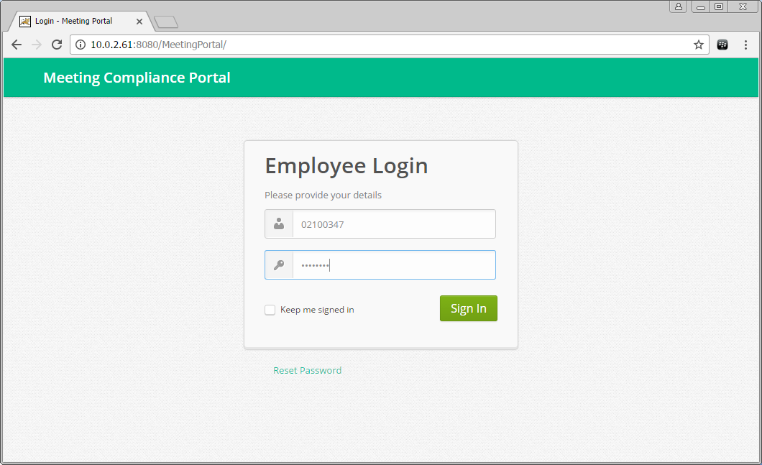

**Dashboard:** Dashboard displays Calendar and Pending Compliance Statastics.

Calendar displays Meeting Schedules.

* Meeting Dates will have a Blue Mark.
* Hovering Mouse over the Blue Mark will display Meeting Titles.
* Clicking on Blue Mark will redirect to Meetings List for the Date.

Pending Compliance Statistics displays Department-wise Pending ATR count.

* The bar graph shows Department-wise Pending ATR count for the meetings conducted by the logged in authority.

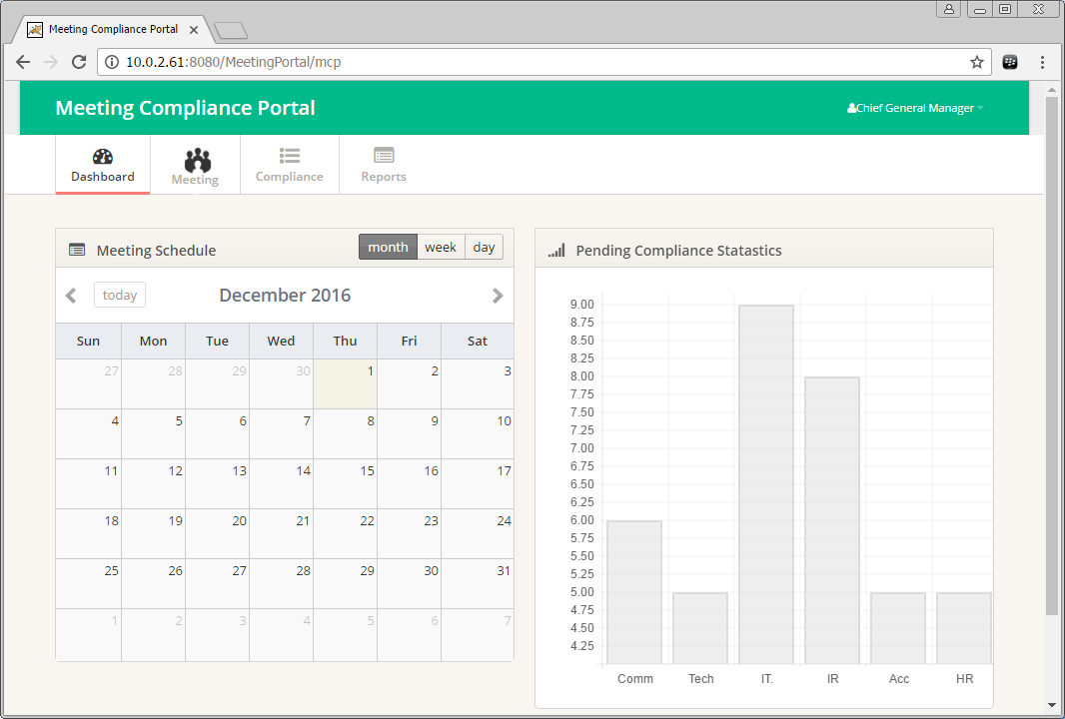

**Upload Meeting (Excel Format):** Meeting Details can be uploaded into the system in pre-decided excel sheet format.

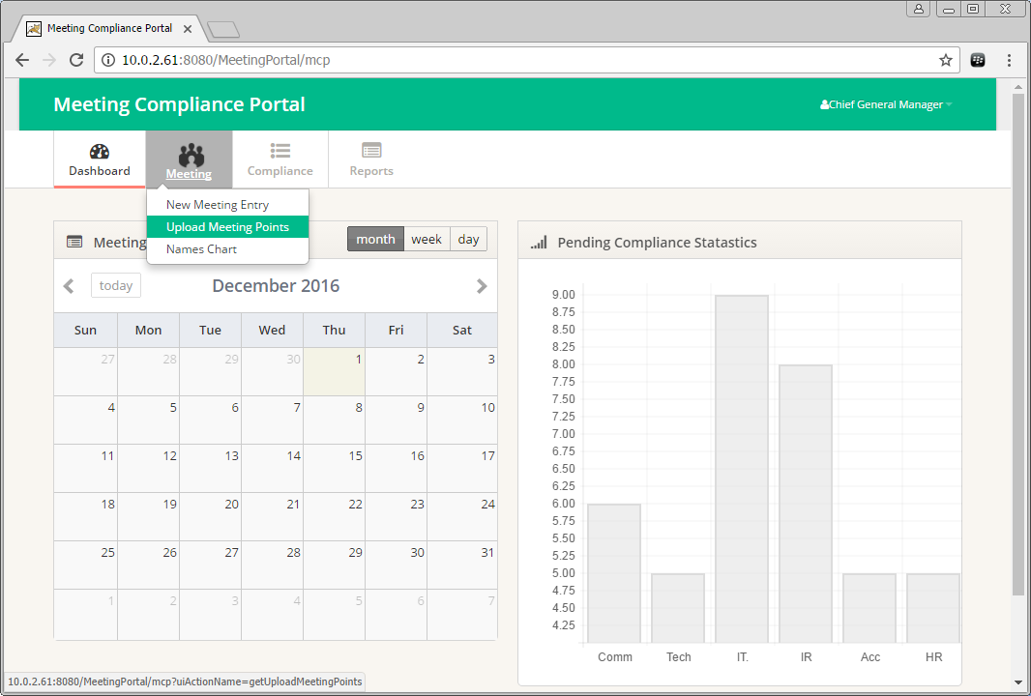

Select a file to upload: Meeting details file (in pre-decided Excel Format) can be uploaded using this screen.

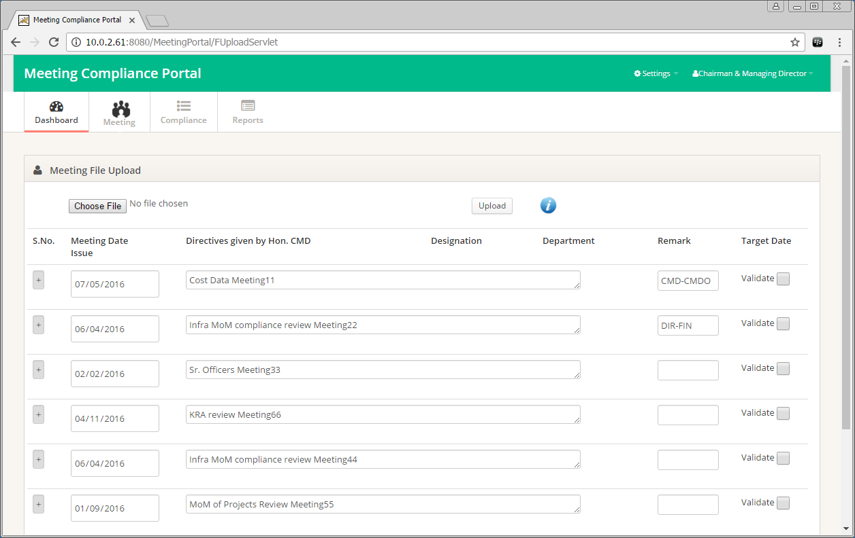

Uploaded data will be displayed on the screen, with collapsed meeting details. Clicking on the [+] icon in **Sr. No** column will display details of all the Directives given by the Meeting Conducting Authority. Corrections can be done before confirming the upload of the data.

Validate the data displayed on the screen by selecting the check box on the extreme right side of the Meeting Title.

Department and Designation short names should be keyed in the excel file, information regarding the short names is displayed under the small icon (i). Proper short names will ensure proper assignment of the directives.

Once ensured that the data is correct, the upload can be confirmed. e-Mails will be sent to all the Concerned HOD’s, from whom the ATR is expected, after the meeting details are uploaded.

**Data displayed on confirmation screen:**

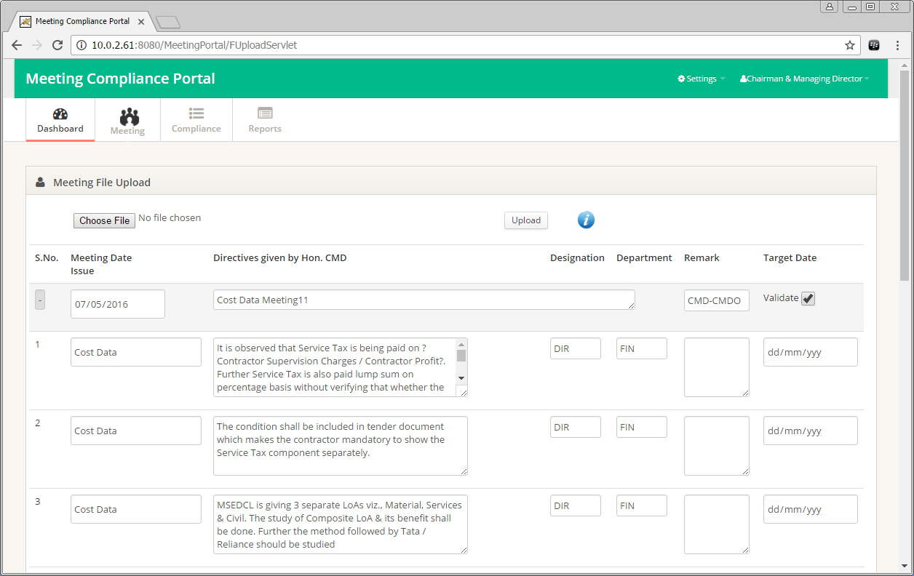

**Department and Designation Abbreviations:**

Names Chart page contains Department and Designation abbreviations, which are to be used in Excel file for uploading Meeting Points.

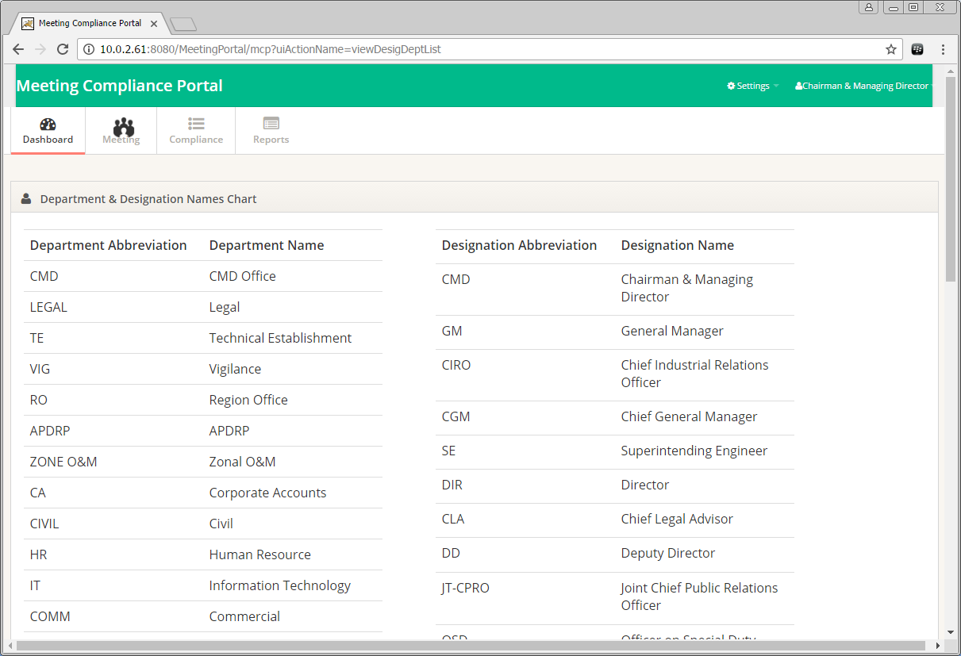

**Submit Action Taken Report:**

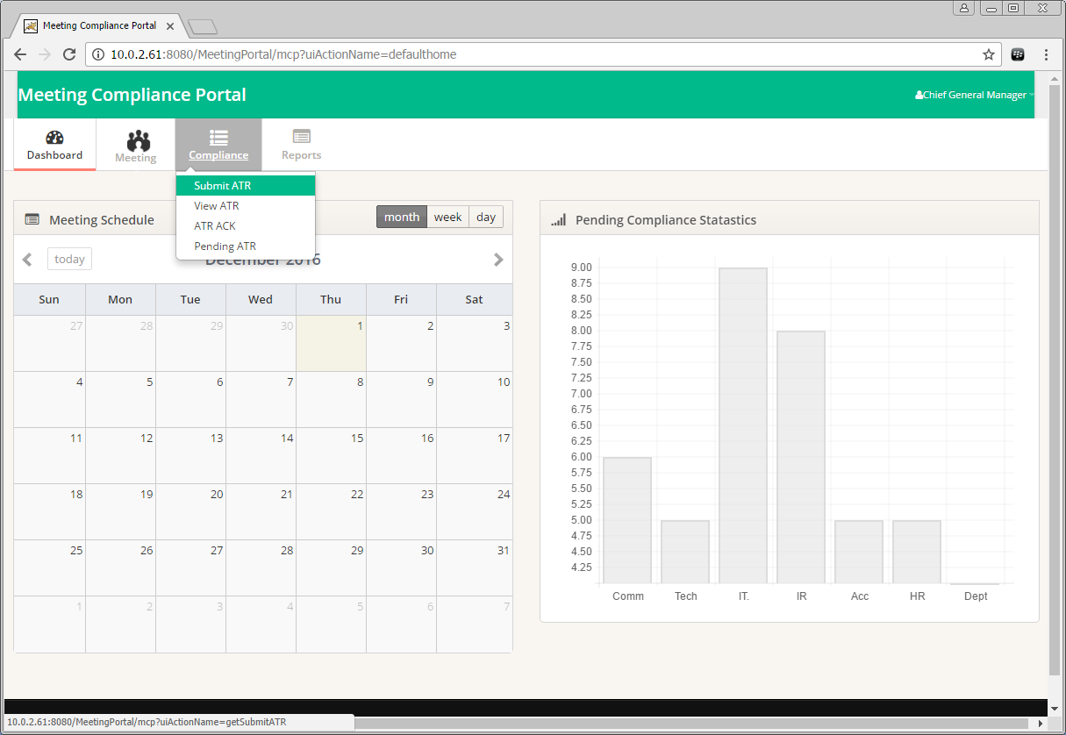

Search can be performed by Meeting Date, Department, Designation and Conducted By.

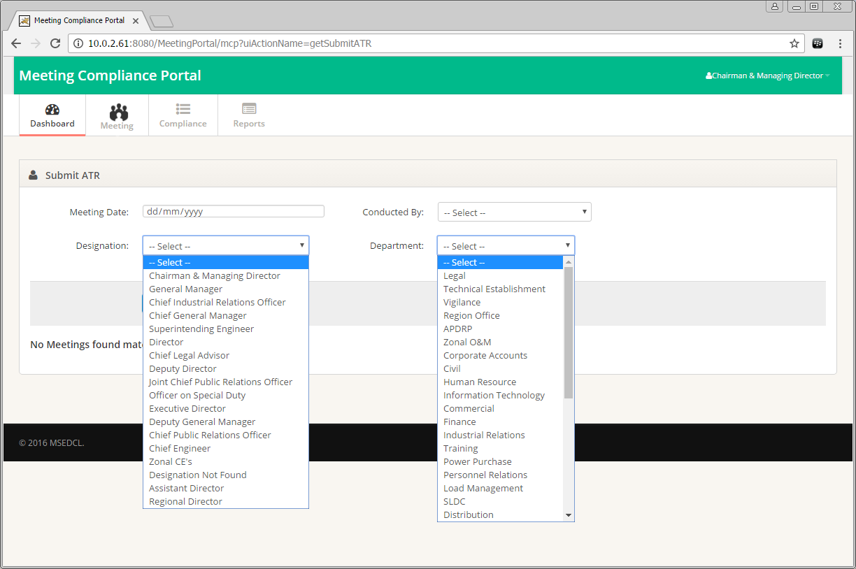

Meeting List will be displayed as per the search criteria.

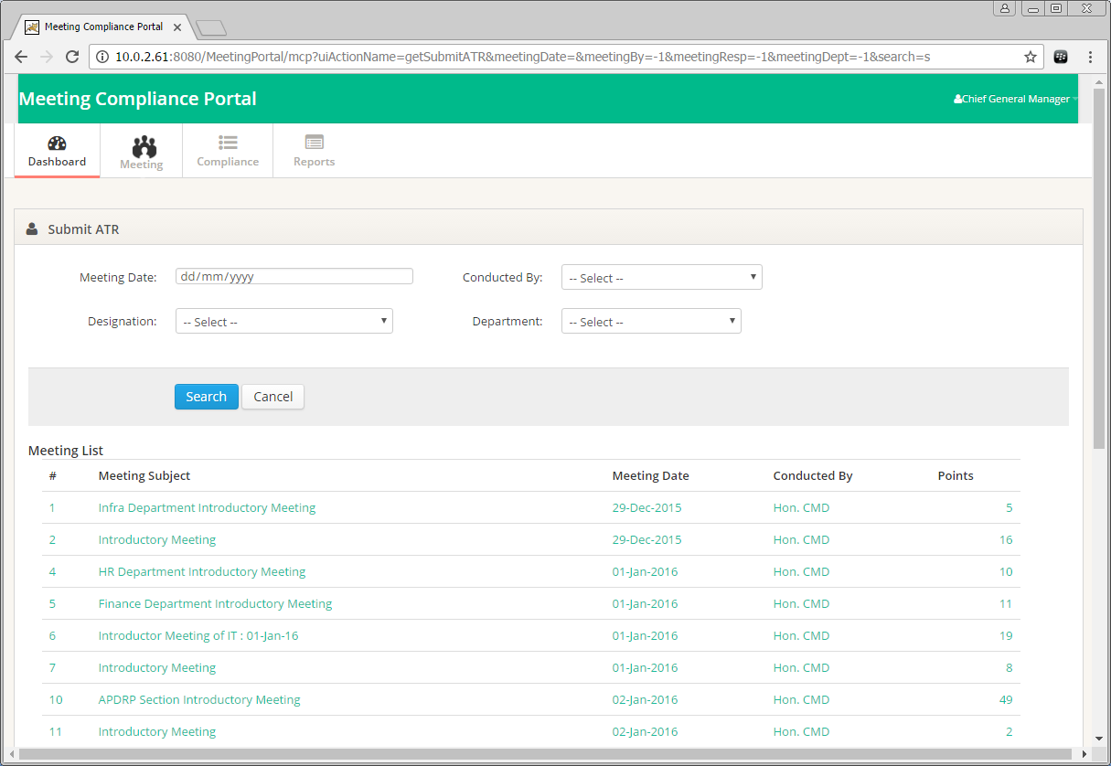

Click on a Meeting to view the Meeting Details.

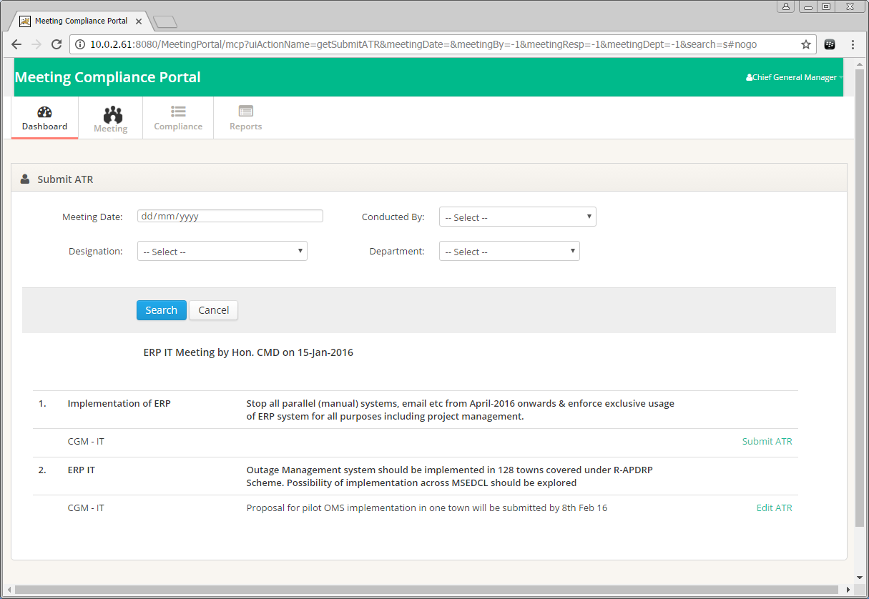

Click Submit ATR to submit Action Taken Report. Pop-Up is shown as below. Enter ATR Details and Upload any Files pertaining to the description. After Entering Details and Uploading Files, click on Submit to save the Action Taken Report.

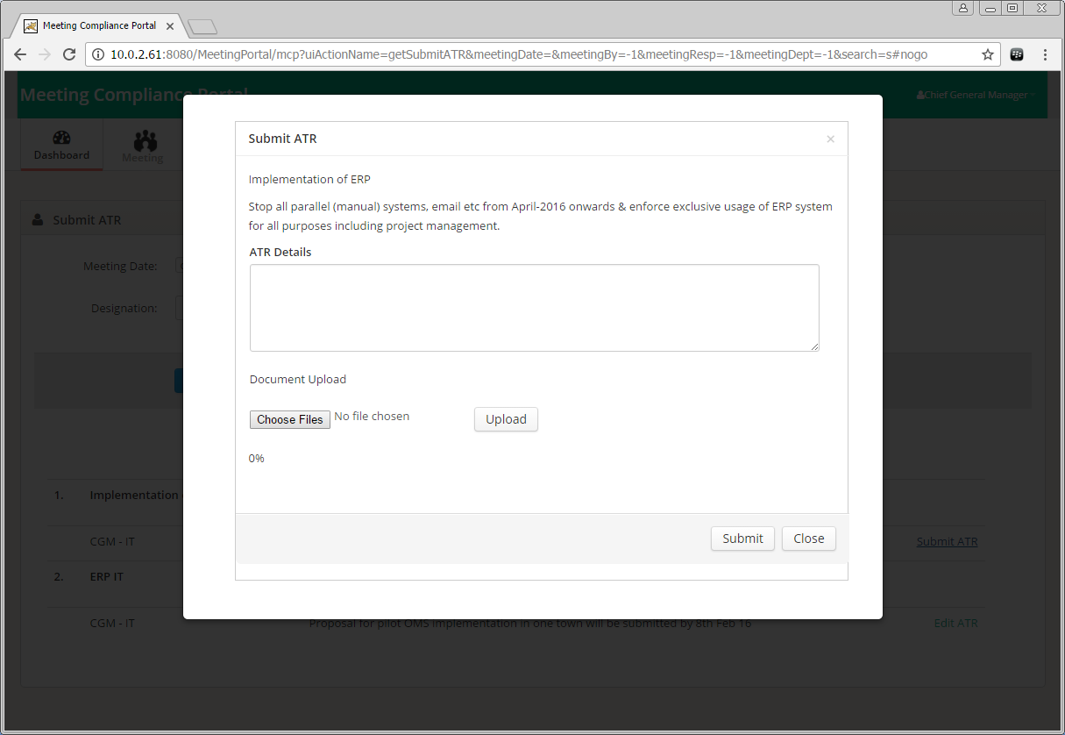

Edit ATR where ATR is already submitted.

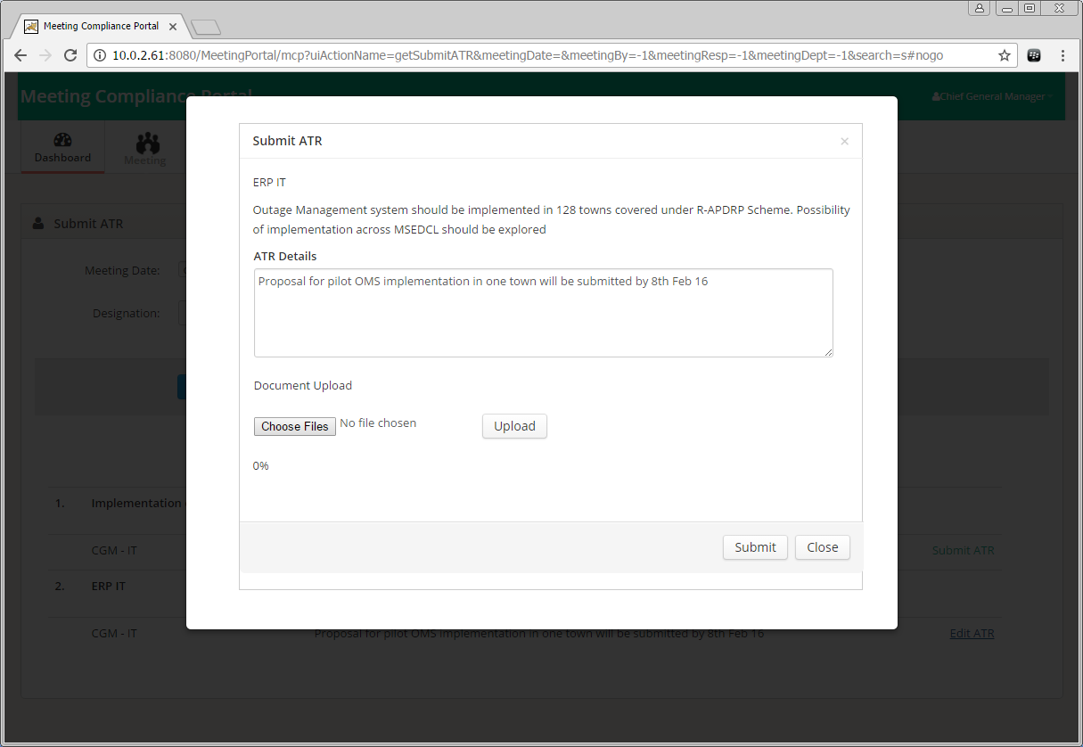

**View Action Taken Report:**

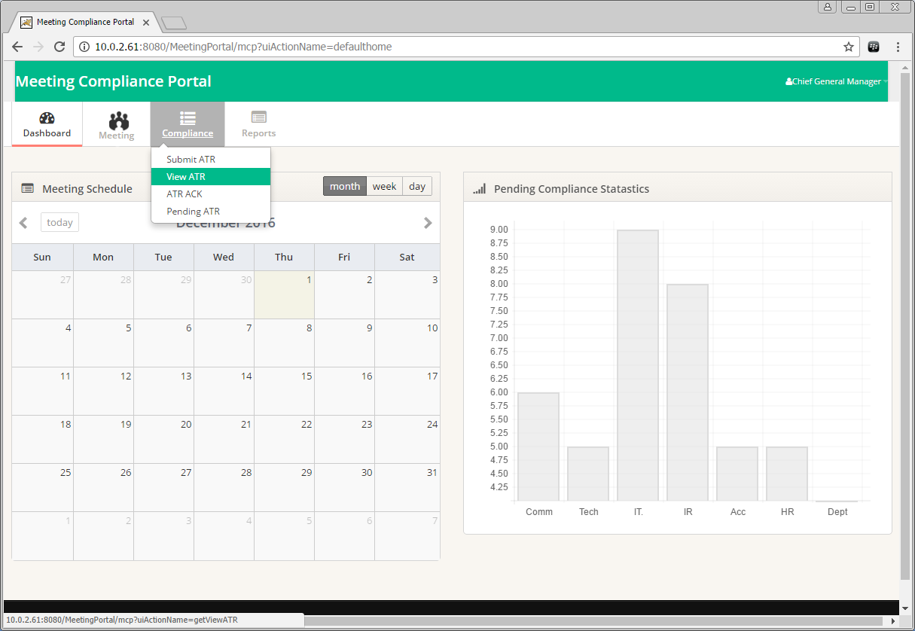

Meeting List will be displayed as per the search criteria.

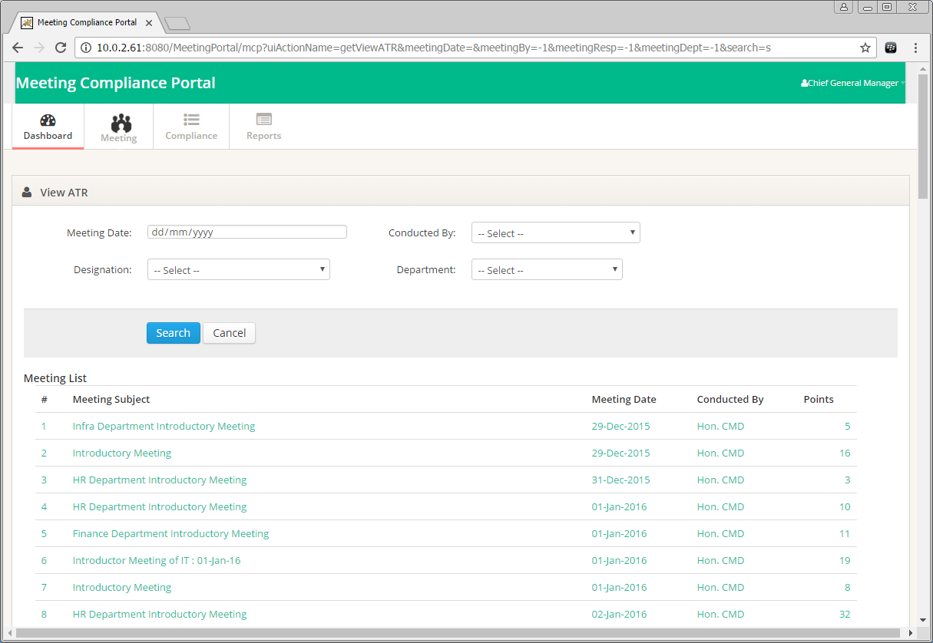

Click on a Meeting to view the Meeting Details.

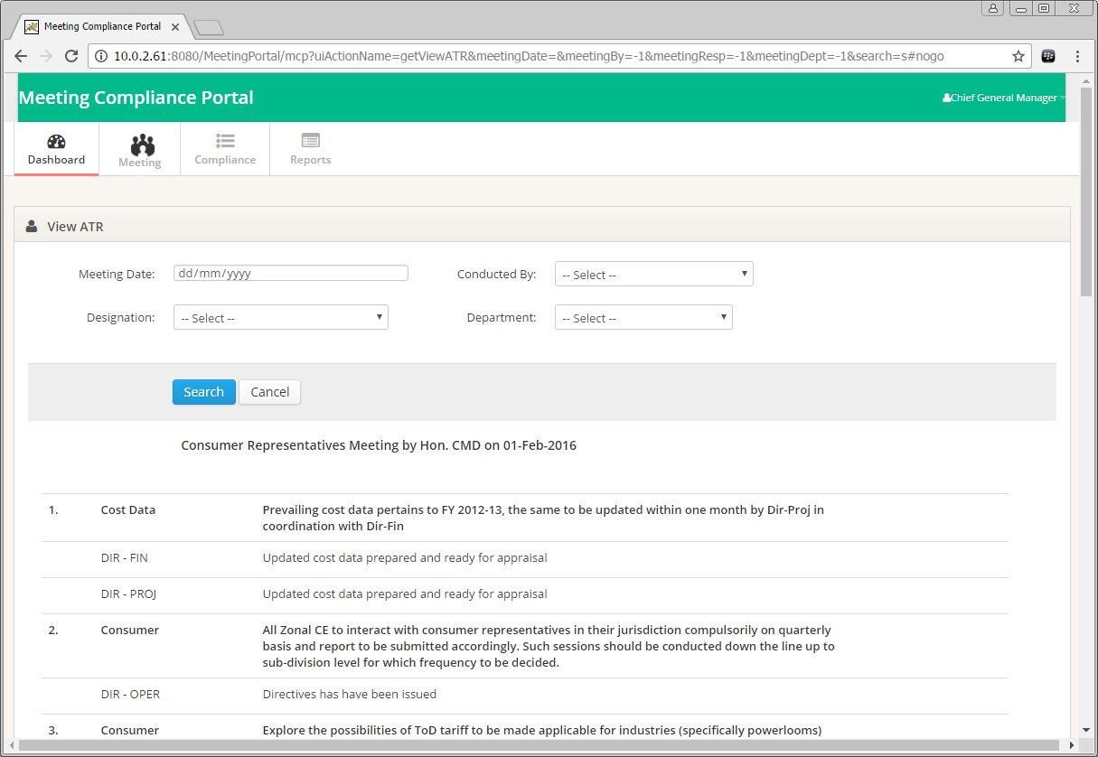

**Acknowledge for Action Taken Report:** ATR can be “Accepted” or “ReAssigned” by the Meeting Conducting Authority.

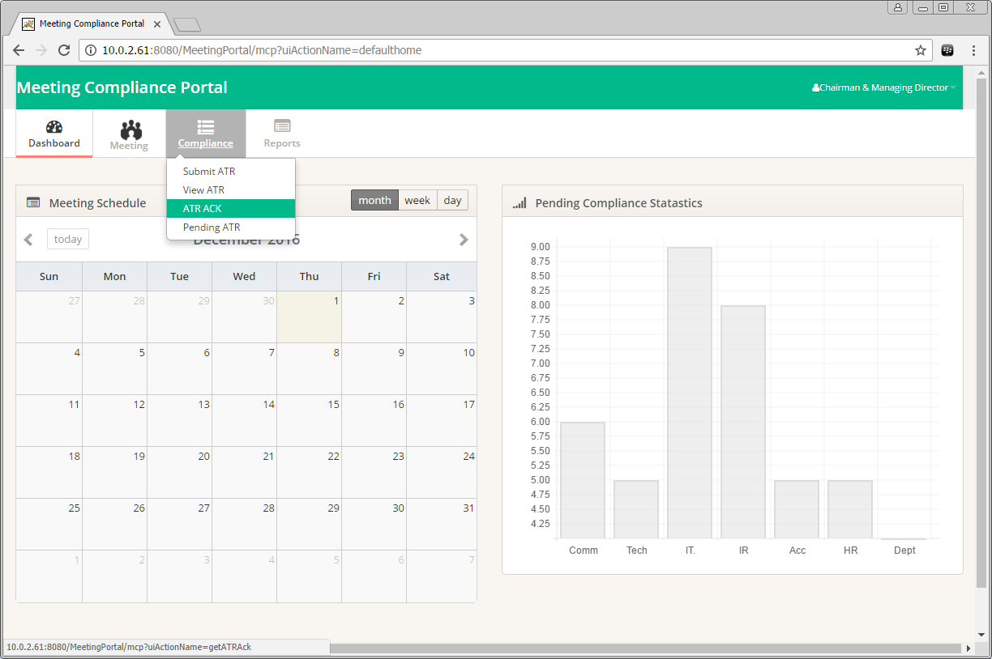

Meeting List will be displayed as per the search criteria.

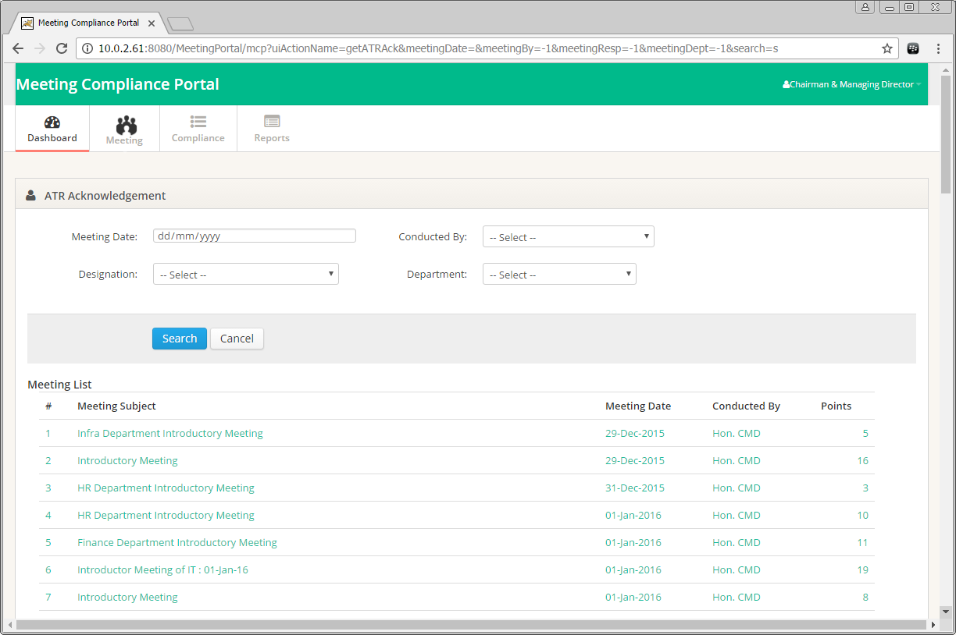

Click on a Meeting to view the Meeting Details. Option to Accept or Reassign ATR can be seen against each directive given. Remark is required for Reassigning an ATR.

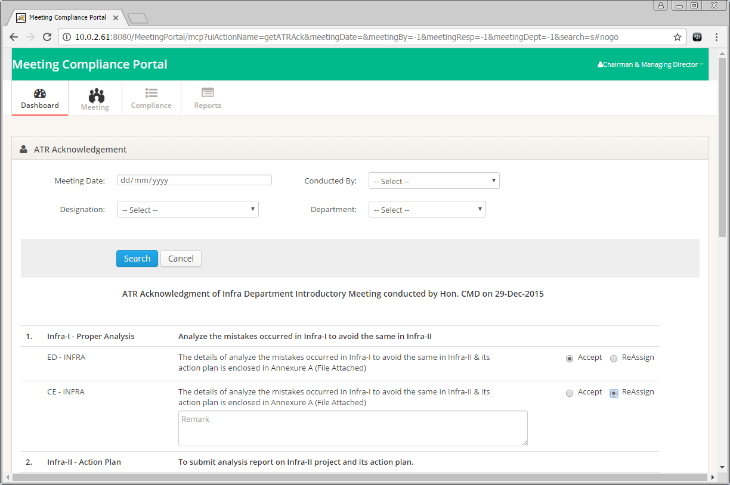

**Pending ATR:**

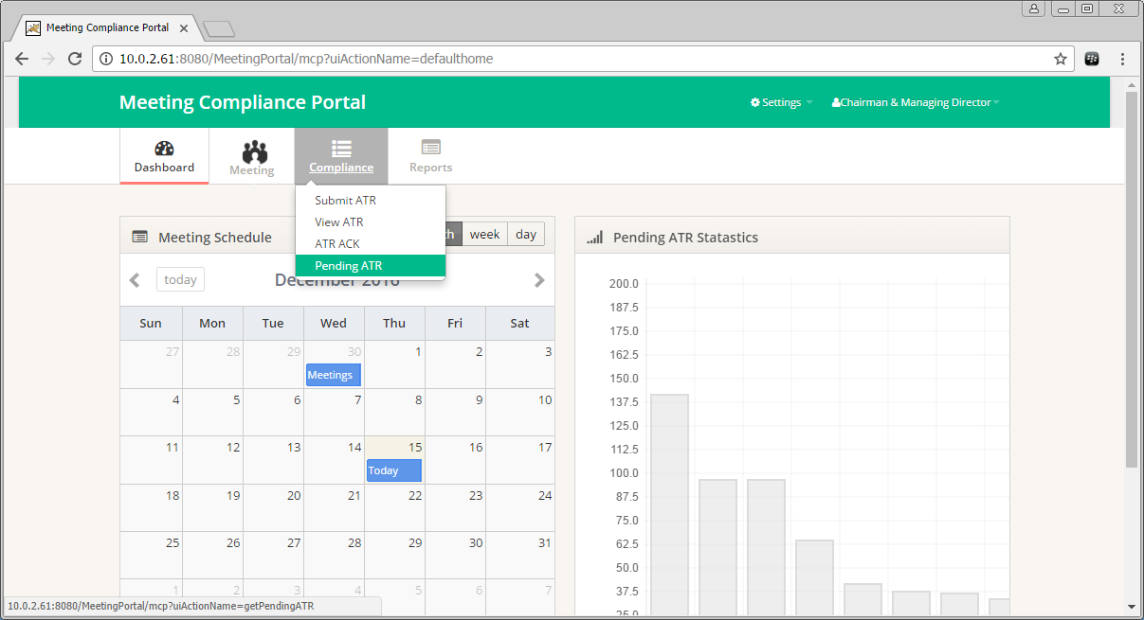

Meeting List will be displayed as per the search criteria.

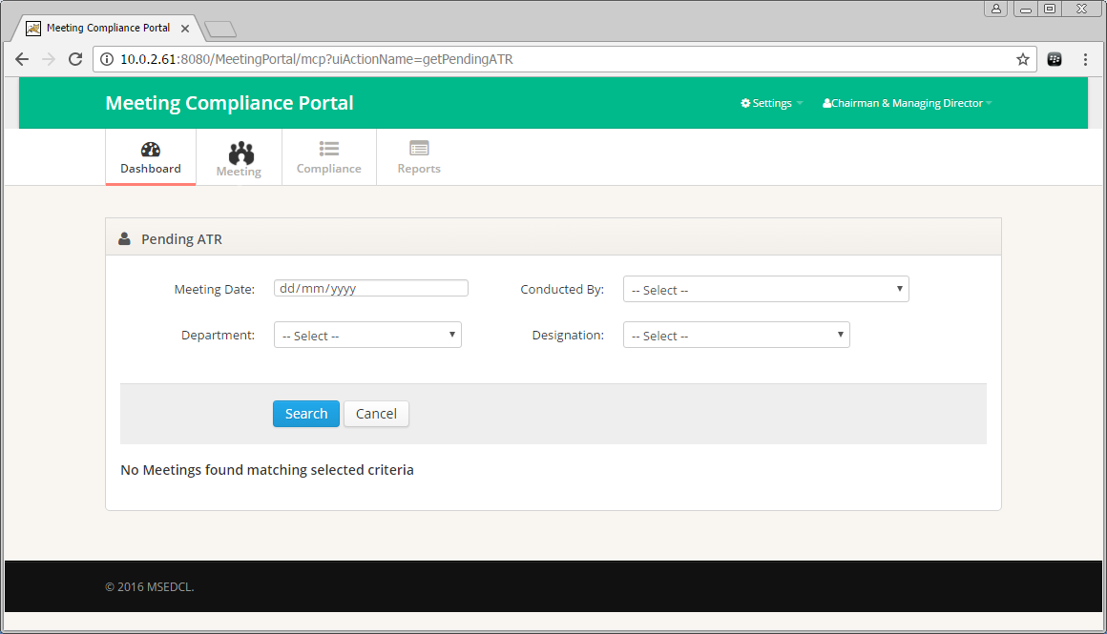

Click on a Meeting to view the Meeting Details.

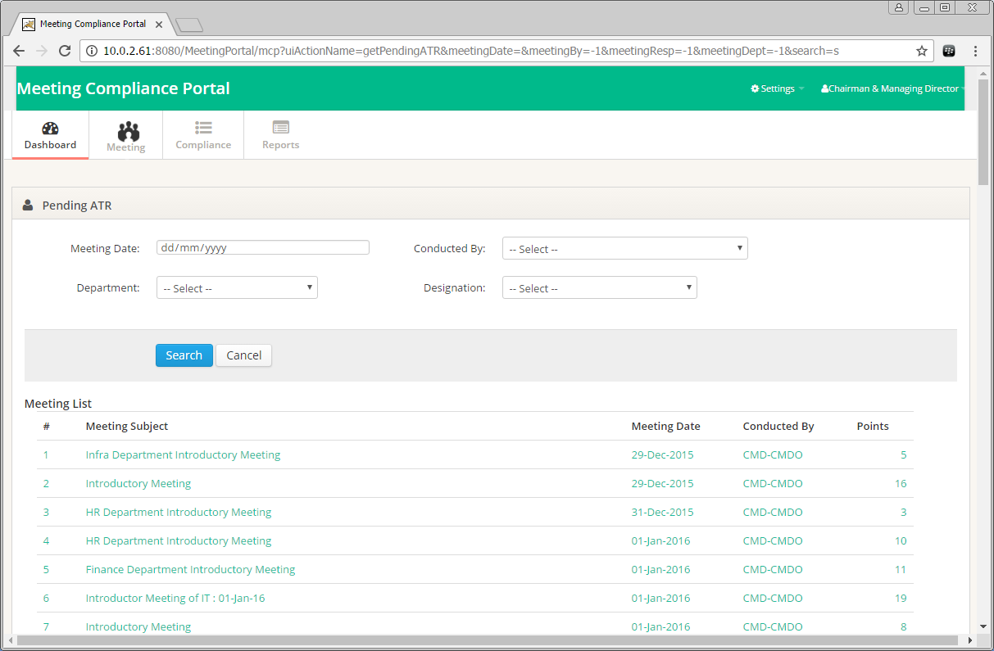

Click on Send Reminder link to send a Reminder e-mail to the Concerned Authority.

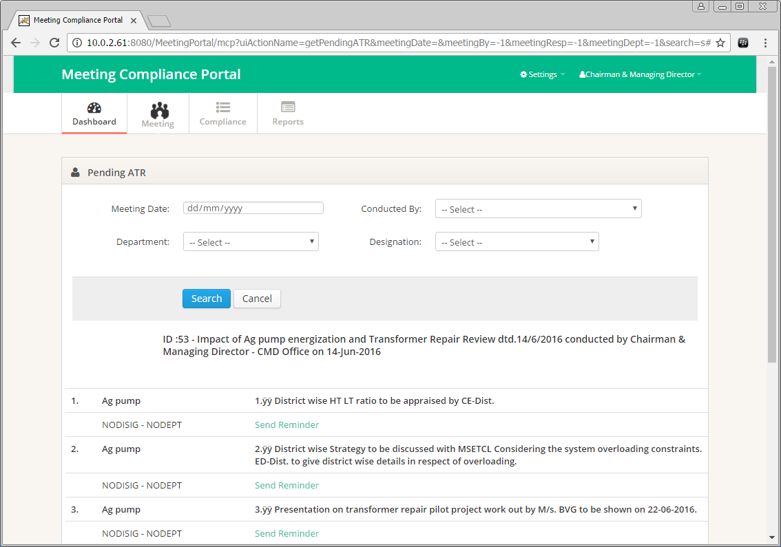

**Reports:**

Meeting List will be displayed as per the search criteria.

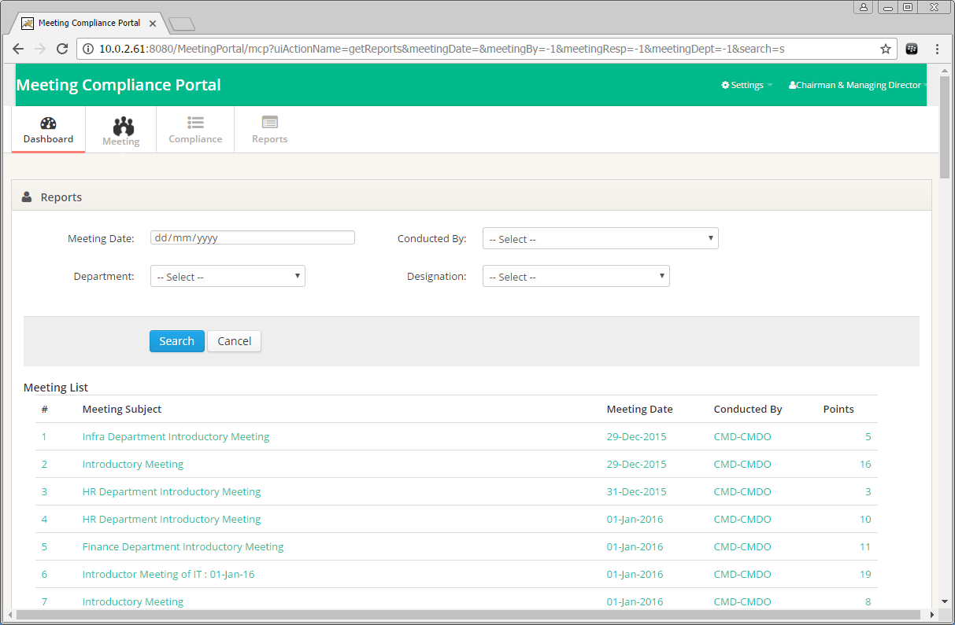

Click on a Meeting to view the Meeting Details.

Report can be downloaded in PDF or Excel formats.

